## 2.Time Converter

Create a program that **converts** different time units. Your task is to add a **click** event listener to **all** [**CONVERT**] **buttons**. When a button is **clicked**, read the **corresponding** input field, **convert** the value to the **three other** time units and **display** it in the input fields.

### Example

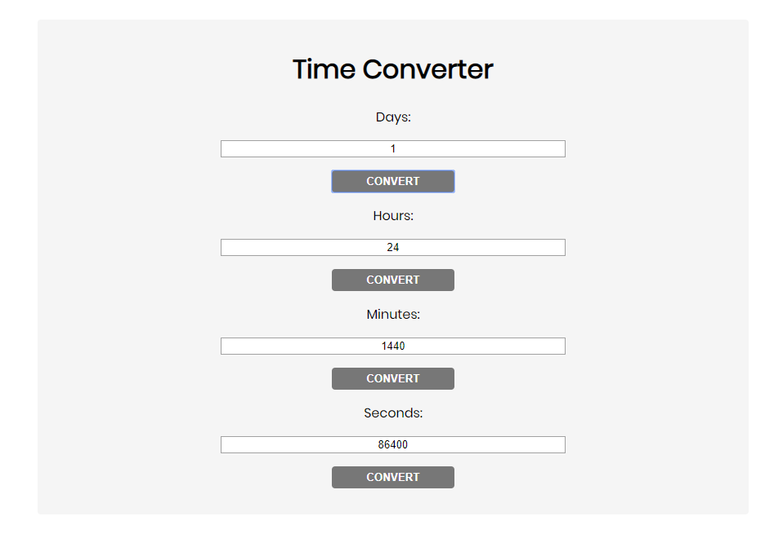

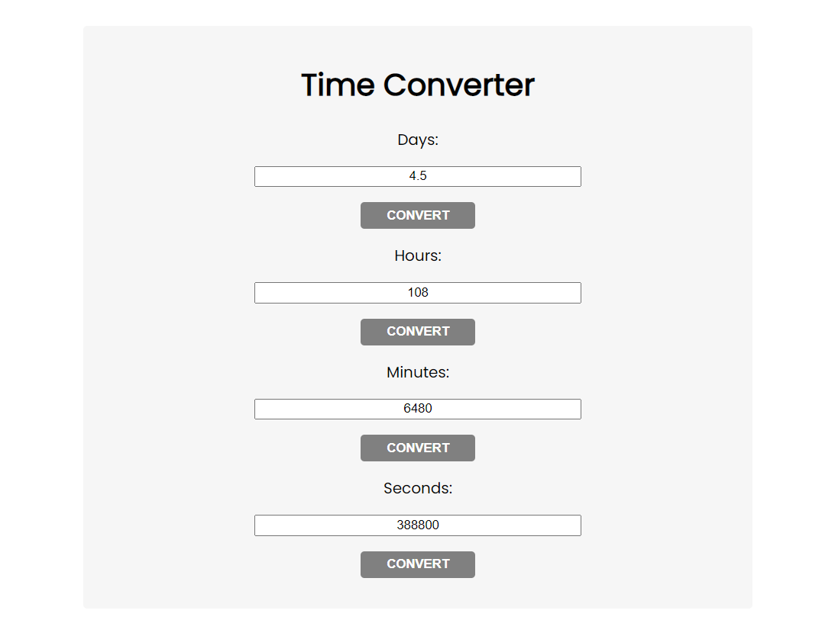

One day is equal to 24 hours/1440 minutes/86400 seconds. Whichever button we **click,** the input fields should **change** depending on the added value on the left. (For example, if we write 48 hours and click convert the days, the field value should change to 2).